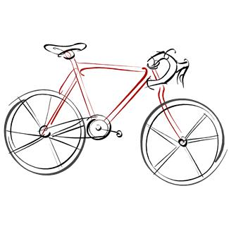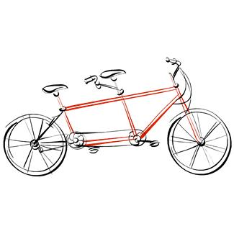

Cyclebag East Ride Programme

Chairman.Sam Swaby Email albertswaby@sky.com
Secretary. Jo Hurst Email johurst@btinternet.com
Treasurer. Brian Baker Email brianalanbaker@hotmail.com
Membership. Patrick Birch Email patrick.birch@virginmedia.com

Meeting Places
Fishponds Fish. The fish structure on the Bristol rail path behind Morrisons at Fishponds
The Winterstream Farm Pub is at the junction of Winterbourne Road and Old Gloucester Road
The Pump House. Pub at the Hotwell Road end of the Harbourside.
Mangotsfield is at the Old Railway Station (Mangotsfield Station) on the Bristol to Bath cycle path.
Coxgrove Hill is where the Yate spur of the Bristol to Bath cycle path meets the bottom of Coxgrove Hill

Day | Date | Leader | Area | Meet | Time | Miles
Sat | Aug19 | Dawn | Tintern Old Railway station. Cafe or picnic | Winter Stream Farm or  Severn bridge | 10am  10.50 | 40-50
Sat | Aug 26 | Patrick | Dundry. Keynsham for coffee, then Whitchurch via Queen Charlton and hill up to East Dundry. Dundry for lunch. Long Ashton, Bristol and home. | Mangotsfield | 10.00 | About 25 miles
Sat | Sept 2 | Sam | Magor. Coffee at Aust Services or Chepstow Garden Centre. Lunch in Magor either picnic lunch in church yard, local cafe, pub or chippie. | Winter Stream Farm | 10am | About 55 miles
Sat | Sept 9 | ***** | Cyclebag holiday starts
Sat | Sept 16 | **** | Cyclebag holiday ends
Sat | Sept 23 | Kay | Whitchurch rail path, Queen Charlton, Saltford, home.  Coffee at Saltford. | Bristol end of the Bristol-Bath railway path. | 10am | 22ish miles.
Sat | Sept 30
Sat | Oct 7 | Jo | Luckington
Sat | Oct 14 | Moira | Caldicot
Sat | Oct 21
All miles are approx. and likely to be shorter if weather is bad or even cancelled if weather is really bad
Please wear bright clothing for your own protection
Please bring lights on all rides, as we can be delayed by punctures, or other unexpected events
Contact Jo with any queries 07941857644 , or by email CyclebagEast@outlook.com

